# DAD 220 Module One Lab Template

## Overview

To complete this lab, go to your Codio virtual lab environment and start a new terminal session. Once there, perform the steps below to complete this activity. Manually enter any commands you are asked to write.

At the end of each step in the activity, replace the bracketed text with a screenshot, brief explanation, or both, as indicated. Size each screenshot and its explanation to fit about one-quarter of the page with the description written below the screenshot. Review the Template Screenshot Example linked in the guidelines and rubric for this assignment to see an example of how screenshots for your assignment should look.

## Create a Database

1. **Create a new database** and update the name to your last name; then connect to it. Type the following commands after the prompt mysql>:
   1. CREATE DATABASE last_name_here;
      1. For example, if your database is going to be named Jetson, then substitute "Jetson" for "last_name_here".
      2. Press **Enter**.
   2. SHOW DATABASES;
      1. Press **Enter**.
      2. You should see a listing of all of the databases (or schemas) in MySQL, including the one you just created.
   3. USE last_name_here;
      1. Press **Enter**.
      2. Substitute the name of your database (for example, "Jetson") for "last_name_here". This SQL statement connects your MySQL session to the database you just created.
   4. Capture a screenshot of the results of this action.

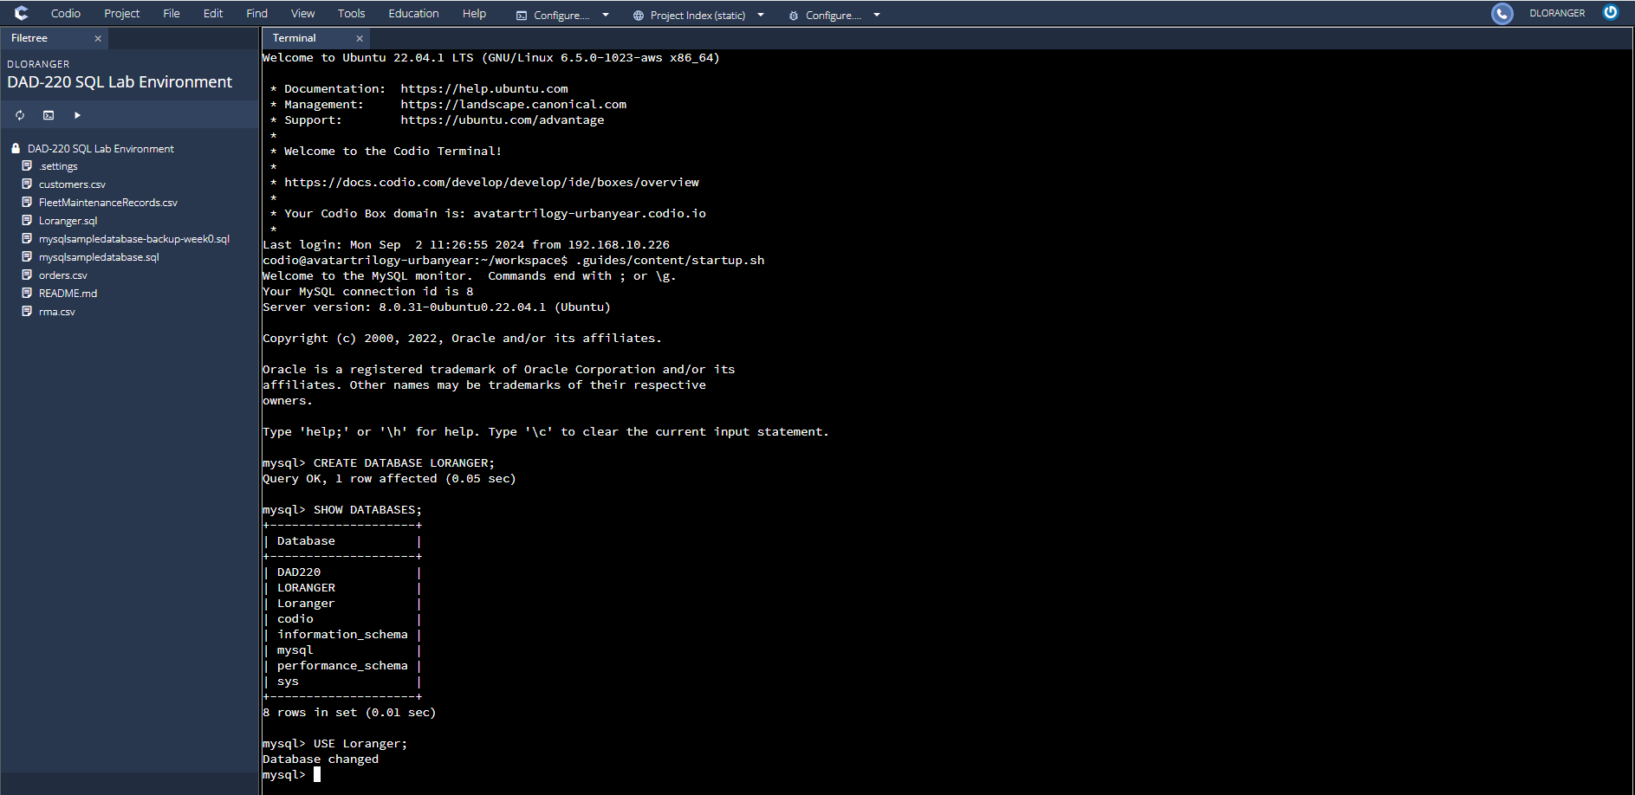

Screen Capture – Execution of subsection 1, steps A-D. All steps completed successfully.

1. **Create a table** called **tb2** and list out the tables in your database with one field by typing the following commands after the prompt mysql>:
   1. CREATE TABLE tb2 (user_id VARCHAR( 50 ));
      1. Press **Enter**.
   2. SHOW TABLES;
      1. Press **Enter**.
   3. DESCRIBE tb2;
      1. Press **Enter**.
   4. Capture a screenshot of the results of this action.

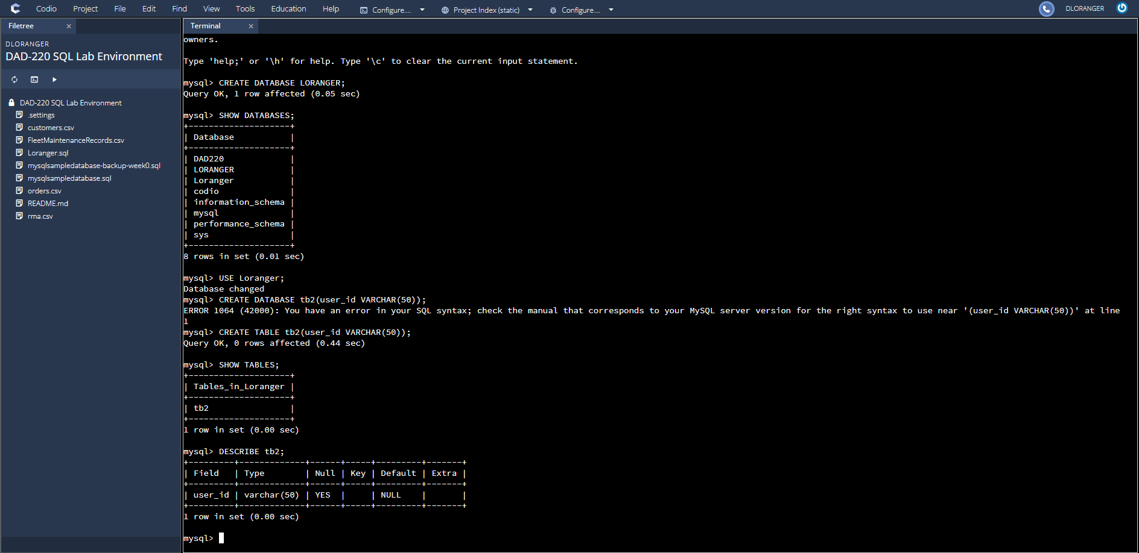

Screen Capture – Execution of subsection 2, steps A-D. All steps completed successfully.

1. **Add a second field into the table and describe it**. Do this by entering the following commands after mysql>:
   1. ALTER TABLE tb2 ADD newfield VARCHAR(25);
      1. Press **Enter**.
   2. DESCRIBE tb2;
      1. Press **Enter**.
   3. Capture a screenshot of the results of this action.

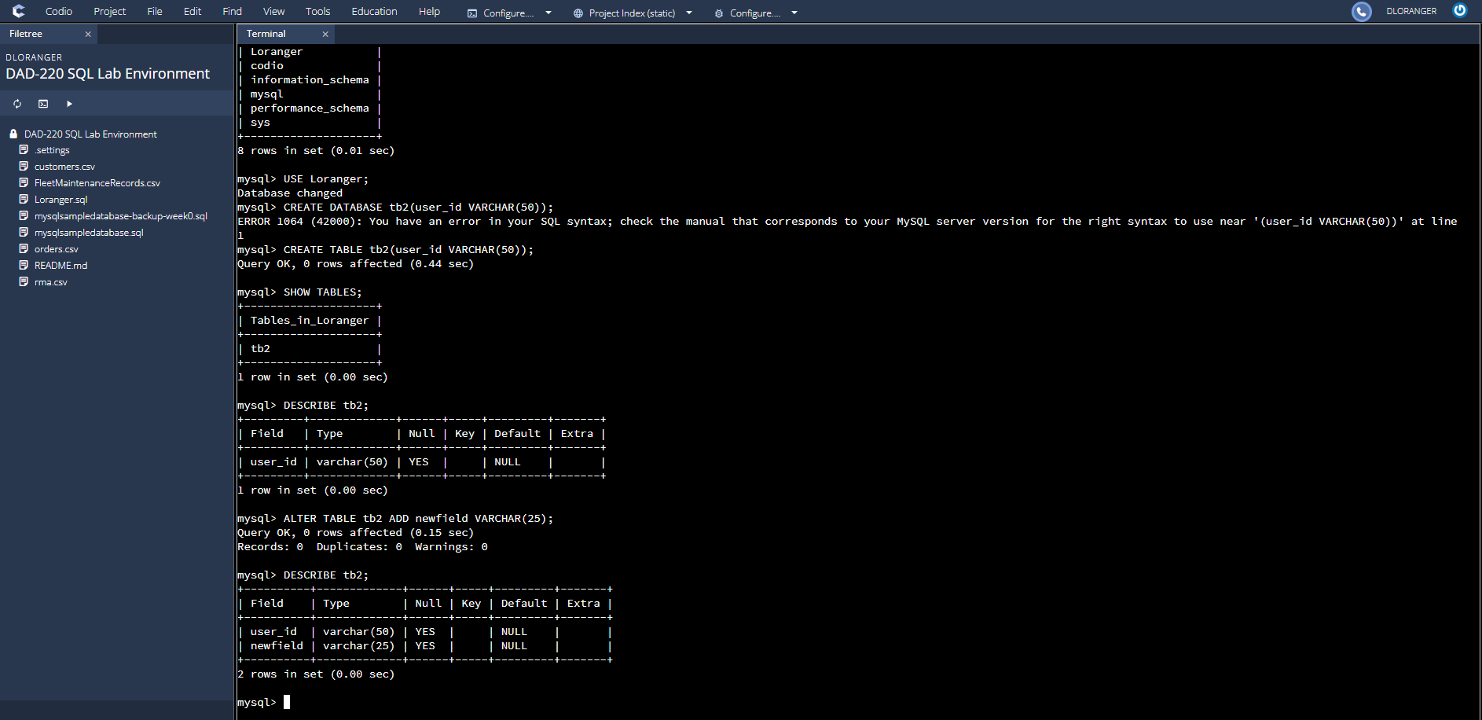

Screen Capture – Execution of subsection 3, steps A-C. All steps completed successfully.

1. **Organize your work** to match the screenshot example and guidelines in the example document linked in the Supporting Materials section of the guidelines and rubric. Your submission should show that your work is original and the commands you have written for this lab worked correctly.